DSA0502 – QUERY PROCESSING FOR DATA SCIENCE
CO1 – AT1 – Data Interpretation
NAME: B KIRTHANAA REG. NO - 192324244

Question 1: Student Examination Analysis

Task:
Read examination datasets from multiple formats. Merge student and marks datasets, calculate total marks, average marks, grade, pass percentage, identify toppers, and export the processed dataset.

CODE:
import pandas as pd

# Read files
students = pd.read_csv("Students.csv")
marks_csv = pd.read_csv("Marks.csv")
marks_json = pd.read_json("Marks.json")
marks_xml = pd.read_xml("Marks.xml")

# Use the CSV marks file for processing
data = pd.merge(students, marks_csv, on="StudentID")

# Calculate Total and Average
data["Total"] = data["Math"] + data["Science"] + data["English"]
data["Average"] = data["Total"] / 3

# Assign Grade
def grade(avg):
if avg >= 90:
return "A"
elif avg >= 75:
return "B"
elif avg >= 50:
return "C"
else:
return "F"

data["Grade"] = data["Average"].apply(grade)

# Pass or Fail
data["Result"] = data["Average"].apply(lambda x: "Pass" if x >= 50 else "Fail")

# Calculate Pass Percentage
pass_percent = (data["Result"] == "Pass").mean() * 100
print("Pass Percentage:", pass_percent, "%")

# Find Topper
topper = data[data["Total"] == data["Total"].max()]
print("\nTopper:")
print(topper)

# Export processed dataset
data.to_csv("Processed_Student_Results.csv", index=False)

# Display final dataset
print("\nProcessed Dataset:")
print(data)

OUTPUT:

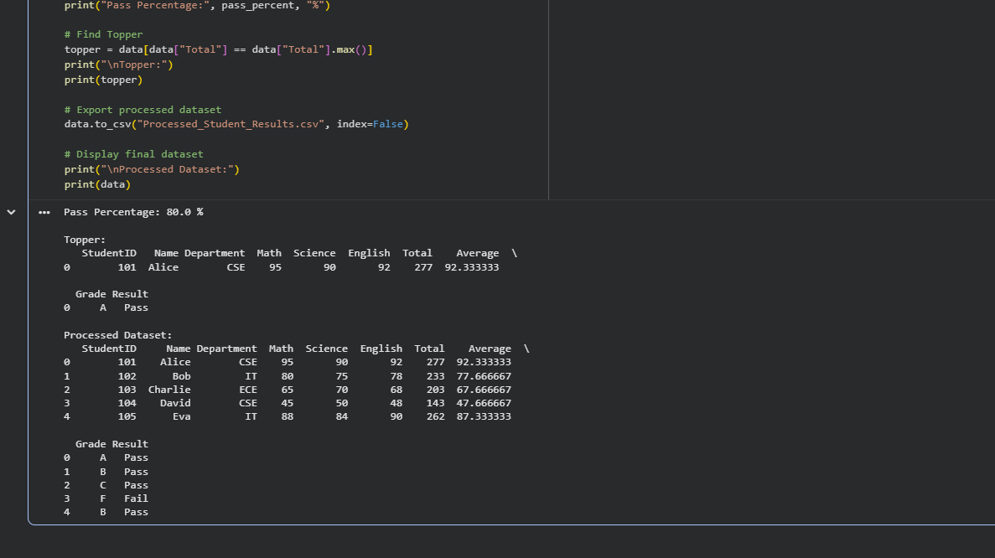

Question 2: Sales Transaction Analysis

Task:
Read datasets from CSV, JSON, and XML formats. Inspect the datasets, handle missing values, remove duplicate records, validate data types, merge related CSV datasets using a common key, perform aggregation and summary statistics, identify the category with the highest value, and export the cleaned dataset to a new CSV file.

CODE:

import pandas as pd

# Read files
sales_csv = pd.read_csv("Sales.csv")
stores = pd.read_csv("Stores.csv")
sales_json = pd.read_json("Sales.json")
sales_xml = pd.read_xml("Sales.xml")

# Inspect datasets
print("Sales Data:")
print(sales_csv.head())

print("\nStores Data:")
print(stores.head())

# Handle missing values
sales_csv = sales_csv.fillna(0)

# Remove duplicate records
sales_csv = sales_csv.drop_duplicates()

# Validate data types
sales_csv["Amount"] = sales_csv["Amount"].astype(float)

# Merge datasets
data = pd.merge(sales_csv, stores, on="StoreID")

# Summary Statistics
print("\nSummary Statistics:")
print(data["Amount"].describe())

# Aggregation
category_sales = data.groupby("Category")["Amount"].sum()
print("\nTotal Sales by Category:")
print(category_sales)

# Highest Sales Category
top_category = category_sales.idxmax()
print("\nCategory with Highest Sales:", top_category)

# Export cleaned dataset
data.to_csv("Cleaned_Sales.csv", index=False)

# Display final dataset
print("\nMerged Dataset:")
print(data)

OUTPUT:

